**AIM:**

Create a table **student** with following fields roll no int (primary key), Name char (20) not null (first letter as either B, S, E, P), sex char (1) accept only m or f, dob date not null, course (values must be MCA, CSE ME), sem(values must be S3, S4), Date_of_Join.

Create second table **marks** with following data Mid in (primary key), roll no int (foreign key) referencing student tables). Sub_code char (5) not null and marks int not null (>=0 &<=100). Insert the data into these tables.

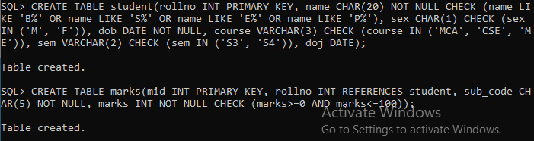

a.       List the name of students joined in mca after 10-10-1990.

b.      List the name of students who are not in CS department.

c.       List the names of students whose names start with ‘E’ and ‘P as 3rd character

d.      List all marks of the student Sourav from MCA.

e.       List all roll no from two table (avoid duplicate roll no).

f.        List all roll no which is common in both tables.

g.      List name from student table and all marks from marks of roll no 23 in student table.

h.      List the roll no and total marks of each roll no from mark table.

i.        Display name and roll no of students, where marks are entered in marks table.

j.        Display the name, roll no, sex, dob, sub_code and mark of highest subject mark.

k.      List the student name and Date of Join in format dd/mm/yy

l.        List all students joined during the year 1998

m.    List the minimum mark of various  students in various department having minimum mark greater than 60.

n.      List all the students in the college other than CS Department

o.      Count the number of students in each department whose mark in greater than 60

**Answers**:

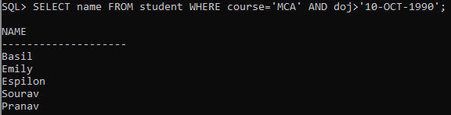

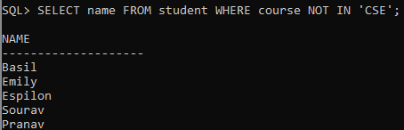



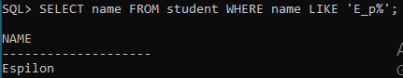



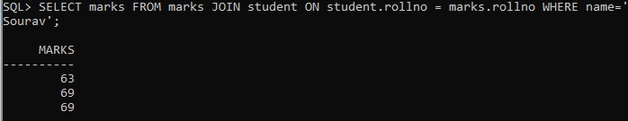



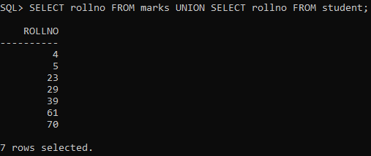



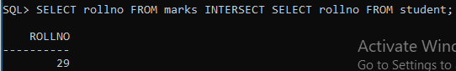



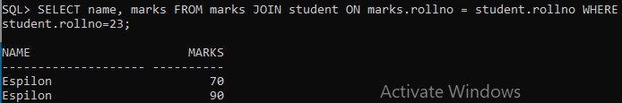



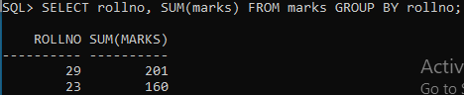



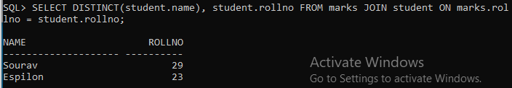

1. 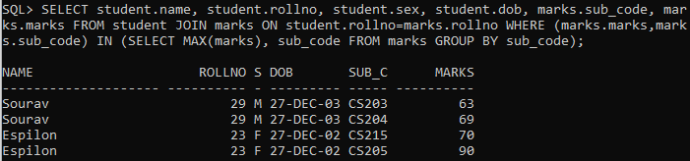

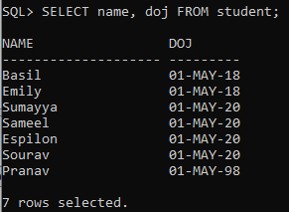



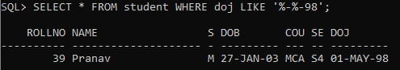



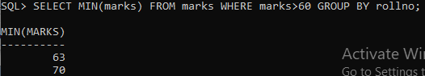



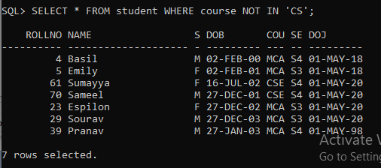

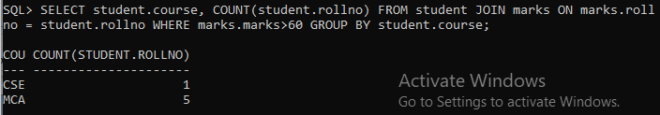

**ER Diagram:**

